Internet Explorers 404, also known as Group 39

GitHub repository: https://github.com/kh-eng-rmit/A2-Group-39-Git

GitHub Pages: https://kh-eng-rmit.github.io/A2-Group-39-Git/

About Team

Ahmed Khalaf (GitHub Pages Link: https://ahmkhalaf.github.io/Assignment-1/)

- **STUDENT NUMBER:** S3967496

- **CURRENTLY STUDYING:** *not provided*

- **BACKGROUND:** Born and raised in Saudi Arabia, but from Palestine, then moved to New Zealand and currently reside in Australia with the ability to speak Arabic and English

- **INTEREST(S):** Software Engineering as a field

- **IT EXPERIENCE:** Scratch from a young age; learnt Python, HTML, CSS, Java, SWL databases with Computer Science courses; 3D Printing

Amy "DeepFryGirl" Lovett (GitHub Pages Link: https://deepfrygirl.github.io/)

- **STUDENT NUMBER:** S3559100

- **CURRENTLY STUDYING:** Bachelor of Information Technology @ RMIT

- **BACKGROUND:** *not provided*

- **INTEREST(S):** Artificial Intelligence as a field

- **IT EXPERIENCE:** Customer Service; Broadened view on IT development, applications and systems

Kaihang Eng (GitHub Pages Link: https://kh-eng-rmit.github.io/)

- **STUDENT NUMBER:** S3964410

- **CURRENTLY STUDYING:** BSc (Honours) Computing and IT @ The Open University (United Kingdom)

- **BACKGROUND:** Malaysian Chinese

- **INTEREST(S):** Information Technology as a field

- **IT EXPERIENCE:** Server Management, Web-hosting, Python, HTML, CSS, PC Building, Basic Networking

Nicholas Kyriakakis (GitHub Pages Link: https://ramsey1234567.github.io/COSC2196-Introduction-to-Information-Technology/PDF/ProjectPDF.pdf)

- **STUDENT NUMBER:** S3814684

- **CURRENTLY STUDYING:** *not provided*

- **BACKGROUND:** Australian, Greek background with the ability to speak English and a beginners level of Japanese and Chinese

- **INTEREST(S):** Finance as a field; IT in relation to the former

- **IT EXPERIENCE:** IT courses during elementary school years; has a father who specialises in IT; hopes to learn more about IT and its skillsets with this course

Personality Profiles

Myers-Briggs



Using the information gathered from the table above:

- Ahmed is an **ISFP-A**, an Adventurer for explorative and confident individualism skills

- Amy is an **INFJ-A**, an Advocate for diplomatic and confident individualism skills

- Kaihang is an **INFP-T**, a Mediator for diplomatic and constant improvement skills

- Nicholas is an **ESTJ-A**, an Executive for being a Sentinel and having people mastery skills

Learning Styles

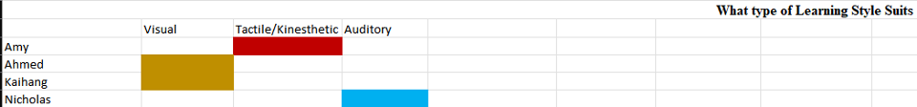

- **Amy** is primarily a **Tactile/Kinesthetic learner**

- Both **Ahmed** and Kaihang are primarily **Visual learners**

- **Nicholas** is primarily an **Auditory learner**

Additional Tests

Ahmed selected a creativity test in which they scored 54 out of 80:

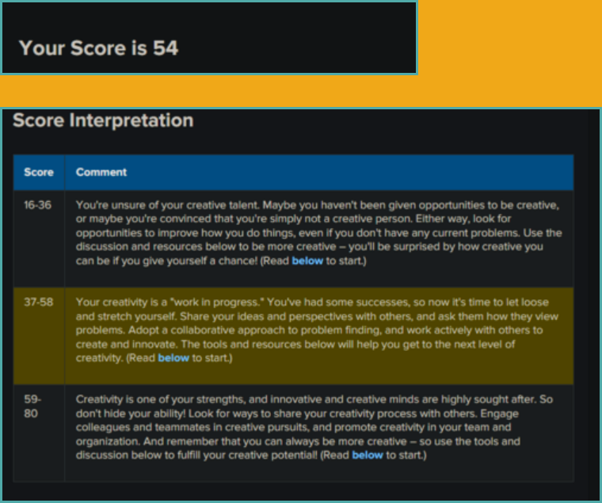

Amy selected Generic Conspiracist Beliefs in which they scored 5 out of 5:

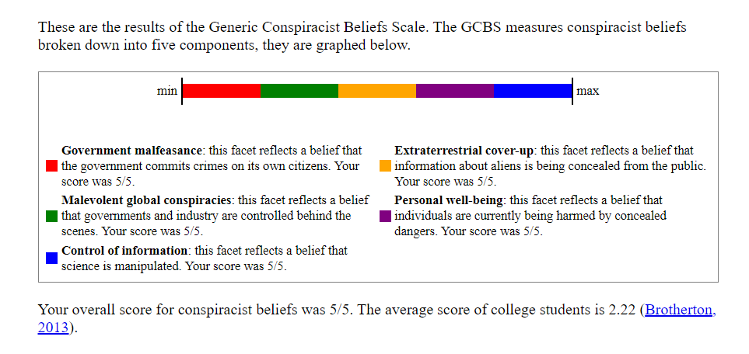

Kaihang selected a creativity test in which they scored 50.91 out of 100:

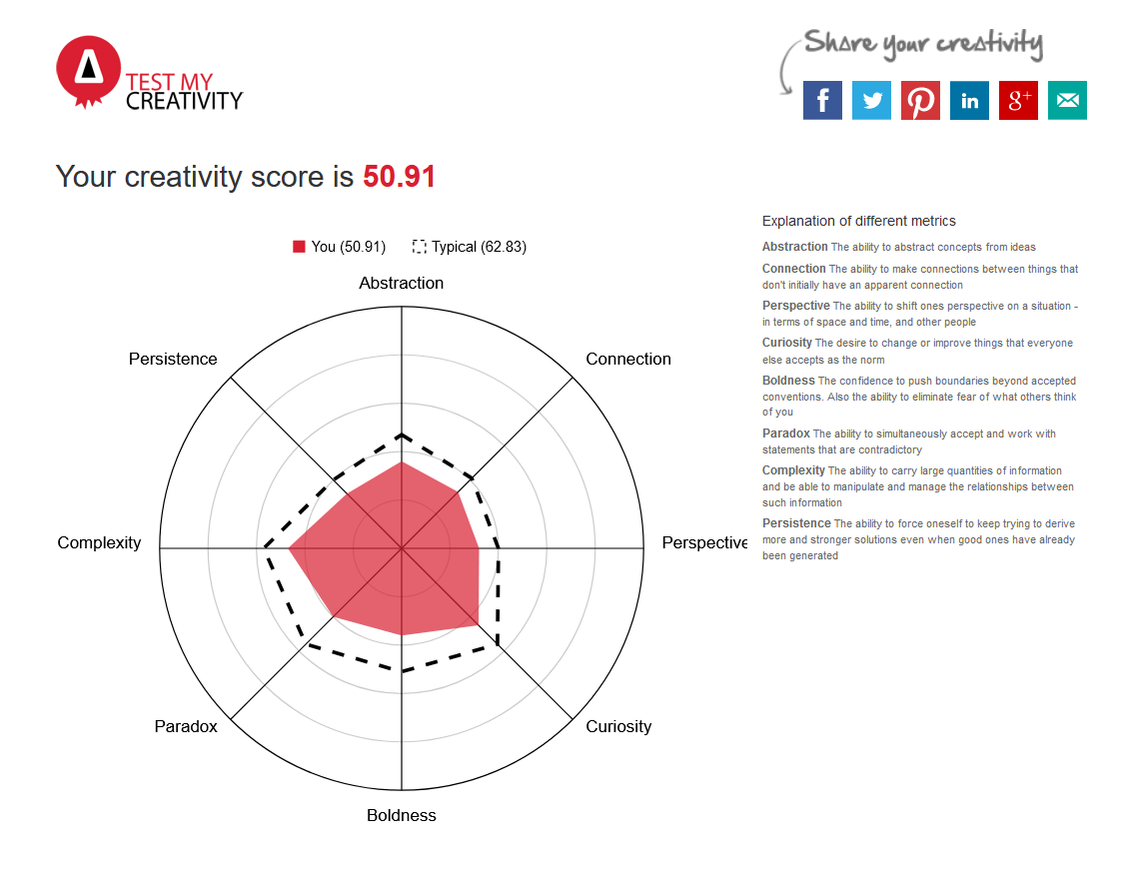

Nicholas selected another personality trait test, OCEAN, in which he scored:

- 60% out of 100% for openness

- 94% out of 100% for Conscientiousness

- 85% out of 100% for Extraversion

- 19% out of 100% for Agreeableness

- 8% out of 100% for Neuroticism

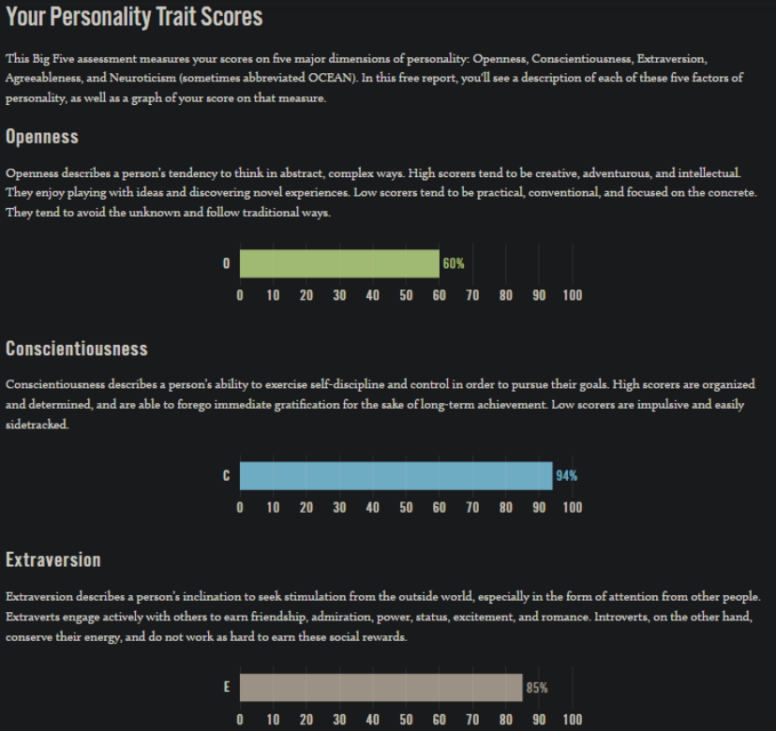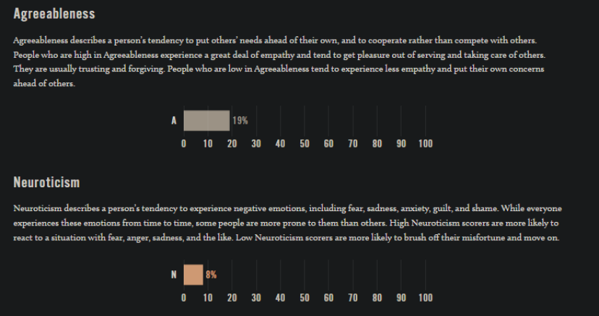

Tools used:

Github:

- an online repository hosting service primarily used to host codebases

- used to consolidate the team's work into one place, as well as the hosting platform for the team's website

Microsoft Teams:

- an online teams communication platform primarily used by businesses

- used to allow communication and coordination among team members

Ideal Jobs

**Ahmed**: Software Engineer

**Amy**: A job focused on AI Specialisation

**Kaihang**: Software Programmer

**Nicholas**: Financial Adviser

Leaving aside Nicholas' financial adviser job selection, the ideal jobs for Amy, Ahmed and Kaihang all involve great uses of computer programming know-hows to create varying different outcomes focusing on certain fields.

A **software programmer** focuses generally on solving problems with pre-existing technological tools and frameworks, primarily through writing and maintaining program codes, documentations and operational procedures.[2]

A **software engineer**, while similar in scope, leans more towards 'providing guidance and expertise in developing proposal and strageties for software design activities', according to the National Skills Commission (NSC).[1]

An **AI engineer** focuses on the creation of their AI system from the start to the end, using various engineering and programming features at their behest.

A **financial adviser**, in our scenario, would work together with the aforementioned job-holders to create advice for their clients.[4]

Industry Data

The job titles for each member's ideal jobs would be:

- Ahmed: **Software Engineer**

- Amy: *undecided; AI-related*

- Kaihang: **Software Programmer**

- Nicholas: **Senior Financial Advisor**

The following are data of employers' demand for each job titles:

Software Engineer (Ahmed)

The NSC states that 'While data are not available for this occupation, projections data are available for the parent occupation, 'Software and Applications Programmers', instead.[1][2]

The reader should refer to 'Software Programmer' section below for projections data.

AI-related Jobs (Amy)

As with software engineer, since AI-related jobs are specialised, it's reasonable to assume that they fall under 'Other Software and Applications Programmers' in ANZSCO.

The NSC states that 'While data are not available for this occupation, projections data are available for the parent occupation, 'Software and Applications Programmers', instead.[2][3]

The reader should refer to 'Software Programmer' section below for projections data.

Software Programmer (Kaihang)

The latest projections data between November 2021 and November 2026 suggests that the number of workers is expected to grow very strongly, from 156200 in 2021, to 198400 in 2026, about 42200 jobs or a 27% increase.[2]

Financial Adviser (Nicholas)

The NSC states that 'While data are not available for this occupation, projections data are available for the parent occupation, 'Financial Investment Advisers and Managers'[4], which we will be using instead.

The latest projections data between November 2021 and November 2026 suggests that the number of workers is expected to grow strongly, from 62100 in 2021, to 68800 in 2026, about 6700 jobs or a 10.7% increase.[5]

Ranking by Employers' Demand

As the NSC does not produce any specific projections data for both Ahmed's and Amy's ideal jobs, they will be included alongside Kaihang's under the all-encompassing industry of software and applications programmers. It also means that comparing by the total workers is infeasible as the industry in question is too broad to make any meaningful comparisons.

Since Nicholas' ideal job is in an entirely different industry, we will instead compare between either industries in terms of growth. Ahmed's, Amy's and Kaihang's industry has a very substantial projected growth of 27% in the next five years, while Nicholas' industry is projected to grow for less than half the aforementioned amount at 10.7%.[3][5]

Required Skills for the Jobs

General Skills, ranked by demand from employers[3][5][6]

- Communications Skills

- Writing

- Problem Solving

- Teamwork / Collaboration

- Troubleshooting

- Time Management

- Decision Making

- Quick Learner

- Mathematics

- Listening

IT-related Skills, ranked by demand from employers[6]

- SQL

- Javscript

- Microsoft Windows

- Java

- Microsoft C# / .NET Programming

- Project Management

- Linux

- HTML5

- Git

- Python

Top 3 General Skills not in the above skillsets[6]

- Organisation Skills

- Planning

- Detail-Orientated

Top 3 IT-related Skills not in the above skillsets[6]

- Building Relationships

- Technical Support

- Business Management

Having looked through the Burning Glass data, the opinion among ourselves on the ideal jobs of the group not only has *not* changed, it has expanded the knowledge of which skill sets each group member may need going forward down their respective path, and reinforced the need for quality education and experience to gain the kind of skills needed.

IT Interview

https://rmiteduau-my.sharepoint.com/:v:/r/personal/s3814684_student_rmit_edu_au/Documents/Microsoft%20Teams%20Chat%20Files/Meeting%20in%20_General_-20220713_195316-Meeting%20Recording.mp4?csf=1&web=1&e=hyfLwg

Cybersecurity

What does it do?

Cybersecurity refers to the safeguarding of computer systems and networks against information leakage, theft, or damage to their electronic data, hardware, or software, as well as from service disruption or misdirection. One of the newest cyber security technologies that is gaining popularity is blockchain security. The foundation of how the blockchain technology operates is the identification of the two participants to a transaction. Each participant in a blockchain is in charge of confirming the accuracy of the data added. Blockchains are also our greatest option right now to protect data from a compromise since they build a network that is almost impossible for hackers to breach. Therefore, combining blockchain technology with AI can provide a strong verification system to fend off any cyber-attacks.

Technology is advancing at an extremely fast pace, especially when it comes to cyber security. With cyber security being one of the most important things when it comes to technology its only reasonable for cyber security to advance with it as well. When it comes to cyber security, cloud computing has been one of its strong points when it comes to advancement. Cloud computing has been advancing at an alarming rate as it is cheap, fast and easy to use. Cloud computing is used to safeguard cloud data, applications, and infrastructure from cyberthreats and attacks, a variety of technologies, services, policies, and best practises are gathered under the umbrella of cloud security. To avoid data loss and aid the company in remaining in compliance with data privacy laws, robust cloud cyber security is crucial.

With the increasing demand for cyber security and the lack of cyber security workers, organizations have come up with the idea of using A.I and machine learning as a way to compensate for the lack of workers. Cybersecurity businesses may now perform ongoing data analytics on monitored data using artificial intelligence and machine learning, which allows them to spot security problems much more quickly and effectively. They have the ability to spot sneaky patterns of harmful behaviour that a human wouldn't see. Similar to this, security automation may continuously find new software flaws, configuration mistakes, and other issues, and ensure that each one is immediately fixed.

What is the likely impact?

Cybersecurity is crucial since it guards against theft and destruction to many types of data. Information systems used by the government and business sectors as well as sensitive data, private information, protected health data, and personal data are all included. A company cannot protect itself from data breach operations without a cybersecurity programme, making it an unavoidable target for cybercriminals.

The development of cyber security, particularly when it comes to cloud computing, will have a significant impact on how organisations operate and how much money they will need to invest to combat cyberattacks and cybercrimes. Businesses may now rely on cloud computing thanks to recent improvements in the technology for cyber security and storing all of their data in the cloud.

The development of AI and machine learning is another significant development that will probably have an impact on cyber security and how it operates. AI and machine learning will have a significant impact because they can swiftly analyse software and check for cyberattacks, saving businesses a lot of money and changing society in such a way that cyberattacks will one day no longer be a concern.

How will this affect you?

The way this will affect me is that I will feel more secure while using the Internet and online applications, which will reduce the risk of being attacked by any malicious malware or cyberattacks. However, this new development in cyber security will have an impact on many people, including my family and friends. This cutting-edge cyber security system Well, if it's not just me, my friends, and family, but everyone, since it's one of the most essential aspects of browsing the web or using an application these days, the development of cyber security is essential as cyberattacks get more frequent day by day.

With these new advancements, forgetting about cyber-attacks may become a thing of the past. How this might affect my family and others is how it could help people, especially the elderly who are vulnerable to cyber-attacks, by assisting them in avoiding it. The development of cyber security will not only help me but also others in many ways.

Autonomous vehicles

What does it do?

An autonomous vehicle is a driverless vehicle using AI technology, and machine learning to adapt to new situations and learn from them on the road, which is able to operate through the ability to see its surroundings, an object can take care of important tasks by itself without the assistance of anyone else.

What is the likely impact?

Autonomous vehicle technology may be able to provide certain advantages compared to human-driven vehicles, like providing increased safety on the road. Automated vehicles could potentially decrease the number of accidents by making fewer errors in comparison to human drivers. Autonomous vehicles may also reduce traffic congestion, by removing human behaviours that cause blockages on the road, such as road rage and people causing accidents by unsafe driving.

If freight transport becomes automated, it is likely that it should take place at night, which would wind up relieving the burden on roads during the day, also truck drivers may not be needed at all anymore in the future with automated cars, and so the costs of freight and passenger transport should also decrease as a result.

Automated cars will benefit us in many ways. Since self-driving cars react faster than a human, the maximum speed can go faster than humans should drive.

Also since many people own a car but it sits not being used for most of the time, there would be opportunities for car rental companies to offer a cars-on-demand that comes to the front when the driver needs it and if everyone used this then we would not need to own cars and would always have access to one when we needed it.

People who cannot drive themselves, because they are too young, too old or blind, will become much more mobile and less dependent on assistance from others because they cannot drive a car themselves, if they had automated cars to do the driving for them then this would enable disadvantaged people to have convenient and reliable access to transportation.

How will this affect you?

Another advantage of Autonomous vehicles is that people who are not able to drive due to the factors mentioned earlier such as old or young age or disabilities such as being blind, for those people to be able to use automated cars, it would help these disadvantaged people become much more mobile and less dependent on assistance from others. It would also eliminate driving fatigue and enable users to sleep during overnight journeys.

It can revolutionise safety on roads and accessibility to places. Self-driving cars would have the same impact on the auto industry that the smartphone had on telecommunication: massive and unpredictable, also creating a ripple effect from everything from petrol prices, fewer emissions, parking spaces, state revenues, jobs, health and accidents insurances costs.

Blockchain and Cryptocurrencies

What does it do?

infrastructure for cryptocurrencies to operate on, while cryptocurrencies are the representation of value that can be transferred from one party to another.

Blockchains are also our greatest option right now to protect data from a compromise since they build a network that is almost impossible for hackers to breach. Therefore, combining blockchain technology with AI can provide a strong verification system to fend off any cyber-attacks.

One of the most significant developments in the blockchain ecosystem in 2021 was non-fungible tokens, or NFTs. For obvious reasons, non-fungible tokens are among the most important aspects of the blockchain's future. The idea of distinctive digital currencies on blockchains was first presented to the world through NFT art that fetched enormous prices in auctions.

The widespread adoption of this blockchain technology will depend greatly on the next five years. Blockchain technology is expected to change the way society and the economy function on a daily basis as the world begins to recover from the pandemic and as ongoing technical advancements continue to expand opportunities for individuals throughout the world. There are a few applications that stand out as leading shifters that will change the world over the next five years, despite the fact that the blockchain business is a rapidly expanding and wide expanse of new technology.

Blockchain technology is being used in decentralised finance, which is expected to grow significantly over the next five years. Decentralised finance is a type of finance that offers conventional financial instruments using smart contracts on blockchains without the use of central financial intermediaries, such as banks.

What is the likely impact?

Its main goal is to create a decentralized environment with no third-party control over transactions and data. Long-term, blockchain might make it possible for operational paradigms across industries to change. Blockchain has the ability to fundamentally alter how we exchange value, transfer ownership, and verify transactions, much like the internet revolutionised how we communicate information.

Blockchain technology may make automated communication faster, safer, and more dependable. In some businesses, automated or digital communication based on pre-built algorithms is already being used extensively. With the introduction of blockchain, hospitals and other healthcare organisations could establish a centralised, secure database, preserve medical records, and only share them with patients and clinicians who had been given permission to do so.

Blockchain and cryptocurrencies are likely to change how we interact with and use money in the future. Given their current level of popularity, it only makes sense that they will eventually replace paper money as our primary form of payment. Digitalizing money may also make it easier for governments to control inflation and other illegal activities like money laundering and tax evasion/fraud.

How will this affect you?

Blockchain Technology has created new opportunities for doing business around the world. Blockchains have made it possible to design more fraud-resistant corporate systems, which has reduced friction by lowering regulatory red tape and reduced costs by removing middlemen. Blockchain is a sophisticated database. Tamper-proof systems can reduce fraud. Records can get lost and sometimes one computer system will not talk to another. Having a system that ensures no record could disappear will improve healthcare systems, streamline everything in our financial lives, and ensure fair trade is operating, as it can track everything from production to trader, everything from coffee beans to diamonds, there would be no more lost records or mysteries regarding wills or inheritances, if everything is put into blockchain, it should have a big impact on our lives in the coming years, and consumers can be confident in their products that they are conflict-free, and not made by slave labour trades. Blockchain will be a lifesaver to any industry drowning in paperwork and especially those with confidentiality obligations.

Machine Learning

What does it do?

A component of AI and computer science, machine learning uses algorithms to act and learn like a human brain to develop.

The complexity of machine learning depends on the task at hand and the technique employed to complete it. A machine learning model analyses data to find patterns; it then makes use of these revelations to carry out the task at hand more effectively. Machine learning can automate any task that depends on a set of data points or rules, such as answering customer service calls and reviewing resumes.

supervised learning, unsupervised learning, semi-supervised learning, and reinforcement learning are the four main machine learning models.

In supervised learning, a computer is given a set of labelled data so it may learn how to perform a human skill. This approach, which aims to mimic human learning, is the simplest.

When unsupervised learning is used, the computer uses unlabelled data to discover patterns and insights that were previously undiscovered. Machine learning algorithms accomplish this in a variety of methods, including

The computer brings together comparable data points to form "clusters" by clustering them.

Density estimation: By analysing the distribution of a data collection, a computer can learn new things.

Data point identification that is notably different from the rest of the data is known as anomaly detection and is done by computers.

In principal component analysis (PCA), a data collection is analysed and summarised by a computer so that precise predictions can be made.

In semi-supervised learning, the computer is given a collection of partially labelled data and is given the task of understanding the parameters for interpreting the unlabelled data using the labelled data.

Through observation of its surroundings, the computer employs reinforcement learning to choose the best course of action that will minimise risk and/or maximise reward. This method is iterative and calls for reinforcement signals to aid the computer in choosing the optimum course of action.

What is the likely impact?

Machines can access more data than any person can. AI can identify trends and use the information to arrive at solutions to previous untenable problems.

Machine learning is used in:

Financial services- to identify important insights in data and prevent fraud.

Government- machine learning can also help detect fraud and minimize identity theft.

Health care- wearable devices and sensors that can use data to assess a patient's health in real time

Retail- retailers rely on machine learning to capture data, analyse it and use it to personalize a shopping experience,

Oil and gas- The number of machine learning use cases for this industry is vast – and still expanding. Streamlining oil distribution to make it more efficient and cost-effective. Analyzing minerals in the ground, finding new energy sources.

Transportation- Analyzing data to identify patterns and trends is key to the transportation industry, which relies on making routes more efficient and predicting potential problems to increase profitability.

How will this affect you?

“Given the rapid pace of research, I expect AI to be able to create new personalized media, such as music according to your taste. Imagine a future music service that doesn’t just play existing songs you might like, but continually generates new songs just for you.”

— Jan Kautz, Senior Director of Visual Computing and Machine Learning Research, NVIDIA

Machine learning will be used and implemented in many ways in our day-to-day lives, and we will see it affect us in ways such as the advancement of technologies in:

Intelligent gaming

Self driving cars and automated transportations

Cyborg technology

Taking over dangerous jobs

Environmental protection

Robots as friends

Improved elder care

Enhanced healthcare

Innovations in banking

Personalised digital media

Home security and smart homes

Streamlined logistics and distributions

Digital personal assistants

Providing customised news and market reports

Project Idea

The idea presented here will be roughly based off what was suggested and outlined by Nicholas.

Overview

An App that is an aggregate of all the various streaming platforms that you have an active membership on.

This App would allow you to search for a piece of media and regardless of what streaming platform it is on, will redirect you including SSO, to that application/media stream with the addition of being able to be used on almost any device and system they come with whether it be for example: apple or android, the application will function for both.

The goal here is to be a quality-of-life changer for the multiple users of the application to greatly reduce one’s time and effort of finding a specific piece of media to view, while at the same time give the user multiple options through a recommend page with a list to various streaming platforms of other potential media which are related to the initial query.

Motivation

The motivation for this project is one out of frustration of having many streaming platforms to chose from at your fingertips but only to find the current one you’re logged into does not contain the piece of media you were looking to view, so you have to log out and log into another platform and if you’re mistaken again you’ll have to repeat it until you have the correct platform, that takes time which this project application will cut down on drastically and offer positive recommendations of other liked media sources to the original one you were seeking.

Also, a key reason to learn new skills by creating the app in the first place is another motivational point and knowing it will be of service to others.

Description

The product being developed is an in-depth piece of search system technology which will solve the problem created by a lack of inter-platform recognition by making it so a user can search various media platforms, this product will be focused on finding a certain piece of media from a varied amount of platforms.

Using the example: The television show Stranger Things, which is broadcasted on the streaming platform Netflix, the program will be able to deliver you to the broadcasters domain of the specified media ‘Stranger Things’ on Netflix and open the program for you, without the need to go through different programs to find that specific piece of media.

The application will need the following to function correctly and be able to give the most accurate information regarding the searchable data, this includes: A database which will be used to store every single piece of media from the various platforms and then use the search function created through programming languages such as Python, to make a directory for the search to acquire the information from the database, which can be put into URL form to give the user a direct link to their destination, in doing so the quality of life of the user is increased to follow up with the different media sources this would then go through a normal networking system by the use of manual input from the user to give them their desired outcome a further example would be just like the Google function of searching a key word and being given links under it, except the main search result will apply to give you the desired media platform and then the additional results will be recommendations of the following key word(s) searched.

Additional search history features as followed; searching through the database on inputs from users, must be a friendly interface that just takes the user exactly where they need to go with no added clutter, can bring up previous request history stored for the person and even mark media as a favourite.

Using different devices, the app will have all if not at least the majority of the major in use systems such as android and apple so the program will be able to function on all devices that the users may have.

The app will also have automatic speech recognition, which is a feature used for those who may have an injury, disability which leaves them unable to use their hands or lack the ability to write therefore they can use their voice to search for the piece of media they need instead.

Two forms of Data collection and caching, in data collection it will have an opt-out function for those who do not want any of their searches being recorded and given to a third-party as privacy to some of the people who use this app will be a top priority, as this also establishes a form of trust with the person using it knowing that nothing nefarious will happen to their data. Data caching so the app will store as much data as possible so it can be functional even without the internet as going back to a previous search it can tell you where you last found that piece of media instead of automatically opening it for you, just given you a reminder that it is there.

Tools

Tools required to produce a project such as this will involve various different features from GitHub as a form of source-control in combination with fork that is an interface for GitHub, then using a integrated development environment such as visual studio 2022 for the basis of being the IDE to create the code for the application using all kinds of programming languages required for the task for example; Python. You will need access to the different phone systems such as android and apple to make sure the technology you’re creating works on both platforms.

Skills

The skills required in the previous project idea remain relevant as listed below.

skills required for this project will involve; Have an understand of programming languages such as Csharp and C++. Interface and database creation which must have significant backend to host the data of the media platforms, easy to use interface such as a cloud system. Find out how to gather information either by user driven APIs or directly sourced from the streaming platforms themselves.

Additional skills required after reviewing the burning glass document to bring more light into the skills area of a project in IT would be critical thinking, judgement and decision making, time management skills, troubleshooting, detail-orientated work, SQL, JavaScript, system analysis, programming and systems evaluation.

Outcome

If this project is successful, it will create that quality-of-life users of multiple platforms have been looking for as a search function between all the possible locations to view a specific piece of media and give them useful and relative recommendations to view other sources instead of just a rough throw together of possible things you might like to see. The original issue was having either too many places to look or not an option to look with the lack of search functionality and the project is able to overcome this by giving the user the ability to be able to search between all platforms.

The key impact areas this will develop is forward thinking going into the future with other programs to have this kind of feature as a baseline and create easier user access to the interface of programs and applications with the simplicity of a google like search bar.

Marketability

This application should be marketed along side of various streaming platforms within the play shop or apple shop to give users the ability to add this on as an additional feature, while it might look as if the application is driving possible consumers away from a platform, it also does the reverse in bringing people to the platform, using the Strange Things example once more someone who has Stan might use the search and realise that the program they want to watch is on Netflix instead and then that could lead to a Netflix purchase, whereas someone with Netflix might want to watch Billions, which could lead to a Stan purchase, so the net gain is really with all the streaming media platforms.

References

[1] National Skills Commission (n.d.) *Software Engineers*, Labour Market Insights website, accessed 24 July 2022. https://labourmarketinsights.gov.au/occupation-profile/software-engineers?occupationCode=261313

[2] National Skills Commission (n.d.) *Software and Applications Programmers*, Labour Market Insights website, accessed 24 July 2022. https://labourmarketinsights.gov.au/occupation-profile/software-and-applications-programmers?occupationCode=2613

[3] National Skills Commission (n.d.) *Other Software and Applications Programmers*, Labour Market Insights website, accessed 24 July 2022. https://labourmarketinsights.gov.au/occupation-profile/other-software-and-applications-programmers?occupationCode=261399

[4] National Skills Commission (n.d.) *Financial Investment Advisers*, Labour Market Insights website, accessed 24 July 2022. https://labourmarketinsights.gov.au/occupation-profile/financial-investment-advisers?occupationCode=222311

[5] National Skills Commission (n.d.) *Financial Investment Advisers and Managers*, Labour Market Insights website, accessed 24 July 2022. https://labourmarketinsights.gov.au/occupation-profile/Financial-Investment-Advisers-and-Managers?occupationCode=2223

[6] Burning Glass Technologies (2018) *Labour Insight Jobs*, RMIT Student Canvas LMS website, accessed 24 July 2022. https://rmit.instructure.com/courses/96748/files/23557937/download?wrap=1

---------

Reflections

Nicholas

Reflecting on the groups performance as a whole, the usage of Microsoft teams and the response time between the members using a rating system out of 10, I would give the group a 2, the reason for this is the extreme lack of responses to the group assignment until the extended due date, which in turn caused me to do the vast majority of the assignment, something I did not plan for and had to cancel other appointments and work to complete.

**What went well:** The only thing that went well within the group, was my own work ethic to get the assignment done, constantly attempting to get the group together to begin and get something done, that persistence might be the reason why the assignment was completed.

**What could be improved:** The only thing that could be improved would be response time and participation of the other group members outside the twilight hour of submission.

**One surprising feature:** The surprising feature throughout the assignment would be the interview with the IT professional as the insightfulness of them and display of the IT industry really opened my eyes to a lot of different variables within the industry that I did not know of.

**One thing learned about groups:** As a baseline just attempt to do everything yourself as you might not know if someone else will contribute.

GitHub as a reflection of the group’s activity shows typesetting done by Amy on the final day, outside of that it does not show group contribution to the actual work being done.

Amy

What could possibly go wrong with a group project?

We have affirmed Murphys Law: Anything that could go wrong, will go wrong.

https://en.wikipedia.org/wiki/Murphy's_law

We all have conflicting availablity, work hours, schedules, and are subject to the common psychology of :"diffusion of responsiblity"

https://www.verywellmind.com/what-is-diffusion-of-responsibility-2795095

- hoping someone else will tell us what to do (looks over and nods at Nicholas).

There were a few attempts made to get the ball rolling initially, but at that stage, nobody had taken lead, until Nicholas stepped in "In the Nick of Time" to save our group project.

Personally, I havent had electricity or internet or hot water for the last week, while I've been in the process of moving house, due to a miscommunications with the provider. Everything that could have gone wrong there, also went wrong there.

Nicholas has taken lead and typed the content, enabling me to upload this to a GitHub page *on the day our assignment is due*.

**What went well:** Having the content all typed ready to go, has enabled me to load this to GitHub.

**What could be improved:** I think making a group project for a class assignment is a terrible idea really, everyone in the class has completely different schedules and work and home life obligations, and availability to complete our study hours, which I was told when enrolling, were "self-paced", so thinking I could slip behind one or two weeks and catch up in the next weeks, is not applicable or suitable for pending group assignent due dates! To get us all working together smoothly was a good idea in theory, but not one that we were able to readily put in to practise. Not starting early enough, timing issues with inactive group members, left an unfair work load on the remaining members.

**One surprising feature:** The IT interview went fantastic. Great Work, Team Nicholas!

**One thing learned about groups:**

The sheer amount of content that is required of this project would have been difficult to allocate suitably within a group.

It would be a better learning experience for us to be focussed more on learning and applying HTML coding, or learning specific aspects of GitHub editors etc,

or doing individual projects, rather than this assignment being so centered around the large amount of content that was involved with completing the requests of the assignement, and organising Team Meetings effectively, which simply did not happen for us.

Ahmed

**What went well:**

Since the group was in shambles and the majority of the group did no work, likely because of other assignments, nothing really went well.

I would like to improve our experience on our next group project, and I hope this never happens again because this group was very inactive and we could have accomplished much more and much better if we had only put our minds to it.

**What could be improved:**

There are many things that could be improved, starting with our communication skills. If our group communicated better, we could move forwards more quickly and effectively; instead, our lack of communication has led to or nearly led to failure for this group. Another thing that could be improved is how we divide the work amongst each of us. This could be done by assigning a group leader, and that group leader could then assign to each member what they would do.

**At least one thing that was surprising:**

One thing that struck me was how no one chose to designate a team leader. In my opinion, a team leader is the most important component of a team, thus the fact that this team isn't doing well doesn't surprise me because we failed to do so. Without a leader, everything starts to fall apart.

**At least one thing that you have learned about groups:**

I know this has been said before, but I have learned that every group needs a leader and that without a leader, a group doesn't actually exist. I have also learned that in order for a group to be effective, everyone needs to pitch in and help out. If we don't cooperate, there may be many uncertainties and conflicts.

Kaihang

**Q: **What went well\*\***

A: I will be honest, the group is completely dysfunctional, because nobody took the lead at any time. Nicholas is the only one that's doing the majority of the work until Ahmed and Amy joined in in the eleventh hour, because of personal issues with life as well as schedule schedule conflicts, and did the rest.

Just to add some context before I continue, I've been officially diagnosed with dysthymia (persistent depressive disorder) and social anxiety disorder, which is why I was able to register with the university's accessibility support.

In hindsight, I should have made this clear with my teammates the first thing we talked, but I've had people accuse me of using my depression & anxiety disorder as an excuse for not being able to do my work before when I truly have no mental energy to handle anything that's even remotely social. My therapist wasn't able to sign my support registration form until late into the assignment either. I hope whoever is reading this can see why I chose not to disclose until now in this document.

I barely got my own personal extension through accessibility support and, by the time I finally managed to both catch up to the syllabus and feeling mentally well enough to start on this assignment, pretty much all the document and research work has been done.

It is my fault for not communicating too much before their deadline, despite already having mentioned to them that I've gotten my extension as soon as I was granted it, so I try to make up as much as I could to contribute my parts once I started feeling well enough and started communicating a lot, which is right after their deadlines.

But, aside from Ahmed responding to me asking for reviews of the website's drafts, all my messages have pretty much been ignored outright throughout the entire 5 days of my extension, when I need feedback for the website and references for the reports they have written.

In the final day of my extension, I've gone ahead and decided to rewrite parts of the documentation, either based off my paraphrasings on the redesigned website, or completely because it made no sense and/or does not include any sources, since I figured out even if I asked for permission to, I wouldn't get any replies back. I'm not able to do enough research in time, and quite frankly exhausted from the frustration, for what the rest of my teammates have written to, either partially or fully rewrite, the entire IT Technologies section.

I can't help but feel that they'd rather move on from this assignment than trying to help me submit my contributions as a team.

So no, nothing went well at all. In fact, I would go further and call it *disasterous*. I'm utterly frustrated with how I was being treated as a team member.

**Q: **What could be improved\*\***

A: There should have been a lot more communication going on in the early stages. I doubt we wouldn't have been in this mess if we had that but without it, we straight up have no leader, which means there's no one to assign any responsibilities to, leading to a lot of overlaps, then it spirals down from here.

I'll have to agree with Amy here, this admittedly-quite-forced group assignment was a *terrible* idea to begin with when you consider that most of the members in this group had to deal with life and their own schedules. The deadline should have been at least 2 weeks later, not one. We all end up getting rushed upon by it, and it doesn't help us submit our best works.

**Q: **At least one thing that was surprising\*\***

A: The very bare amount of communications and coordination right up until the last minute possible, and I can't assign any faults to anyone in this team considering everyone's circumstances. But, if there is one thing I can definitely blame my teammates for, it's for the exact same reason between their deadline and my extension's deadline, where I needed help and feedbacks the most.

**Q: **At least one thing you've learned about groups\*\***

A: I'm basically repeating myself here, but there needs to be a *lot* of open communications and coordinations as well, with or without a leader, in order for a group to be effective in the first place. Without it, everything just falls apart.